CUT THE PREJUDICE!
different religious traditionS through the lens of a camera
Berlin, Germany, 11th-17th of April 2016

APPLICATION FORM
Please return this application form by 6th of MARCH 2016 midnight CET

1. APPLICANT’S PERSONAL DATA
Surname(s) (as in passport):
First name(s) (as in passport):

Street address:
Postal code:
Town:
Country:

Please provide at least one telephone number or one e-mail address where you can be reached for quick communication.
Telephone:
E-mail:

Gender:
Date of birth (day/month/year):
Place of Birth:

Profession or Occupation (if student, which field):
Religion:

Sending organisation, if any (full name):
Contact person in organisation (full name):
E-mail of the contact person:
Endorsement of the sending organisation (Why do you nominate this participant?):
Signature of the contact person:

2. PASSPORT AND VISA
Please indicate if you need visa for Germany (Y/N):If yes, please, indicate the name, address and fax number of the Embassy to which you will submit the needed documents and fill in the passport details below:

Nationality (country issuing your passport):
Passport number:
Date and place of issue:
Passport valid until:
3. LANGUAGES and special needs
The working language of the study session will be English, please indicate the spoken and understood level of your English knowledge (1=poor ... 5= very good):

Do you speak other languages? Which?:

Do you have any meal requirements, please specify (i.e. halal, kosher, vegan, allergies, other)? (Y/N):

Do you have any medical conditions you would want us to know about, in order to make your stay safer?

If yes, please, specify (e.g. diabetes, epilepsy, asthma or other we should know about):

4. MOTIVATION (please new sheet for this)
a. What is your motivation to participate in this training course?

b. How will you contribute to the success of this training course?

c. What does “cut the prejudice”, in an interreligious perspective, mean for you?

Date and Place:
Signature of the Applicant:

Please return this application form by 6th of MARCH 2016 midnight CET to applications@eyce.org!

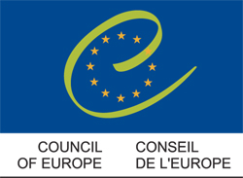
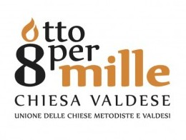
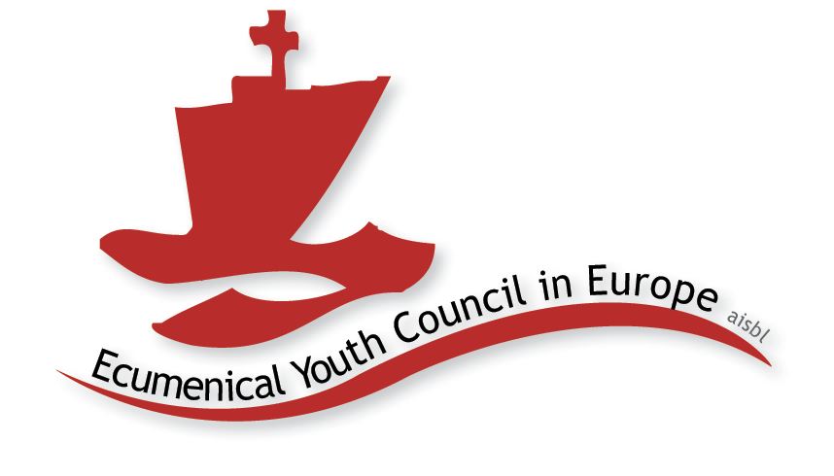
Should you have any further questions, do not hesitate to contact us!
We hope to see you in Berlin!!!

